6.47: The power is 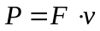. F is the weight, mg, so So, 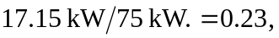 or about 23% of the engine power is used in climbing.

